Methodology
This section outlines the methodology employed for training a Convolutional Neural Network (CNN) model using the EfficientNetB3 architecture for image classification.
1. Data Preparation:
- Data Collection: The dataset comprised images of rice plants, categorized into different disease classes.
- Image Resizing: All images were resized to 224x224 pixels. This standardization ensured consistent input dimensions for the CNN model, improving computational efficiency and facilitating model training.
2. Data Splitting and Distribution:
- The dataset was split into training, validation, and test sets using a stratified approach to maintain class distribution across each subset.
  - Training set: 80% of the total dataset (8325 images) was allocated for model training.
  - Validation set: 10% of the total dataset (1041 images) was reserved for hyperparameter tuning and model evaluation during training.
  - Test set: The remaining 10% (1041 images) was kept separate for final model evaluation and performance assessment.
  - Data Distribution: As illustrated in the pie chart below, the data was distributed proportionally between the three sets:

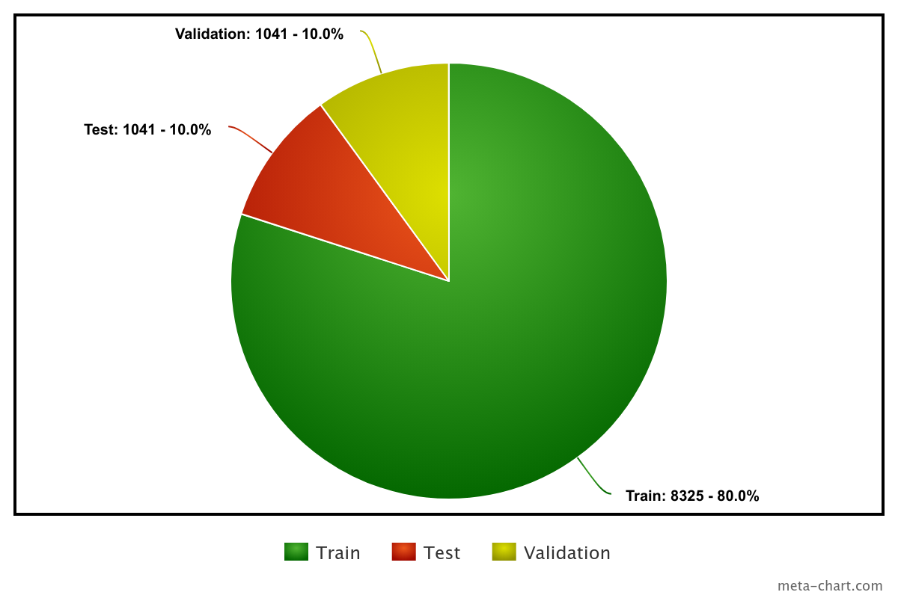

3. Data Augmentation:
- Standard data augmentation techniques were applied to the training data to increase the model's robustness and generalization ability. This included techniques like random cropping, flipping, and rotation.
4. Model Training:
- Model Architecture: The EfficientNetB3 architecture was chosen due to its efficiency and performance on image classification tasks.
- Training Parameters: The model was trained for 20 epochs using the Adam optimizer with a learning rate of 0.001.
- Loss Function: The Categorical Cross-Entropy was used as the loss function to measure the difference between predicted and true class labels.
5. Model Evaluation and Metrics:
- Classification Reports: After training, a comprehensive classification report was generated to assess the model's performance across each class. This report included metrics like precision, recall, F1-score, and support.
- Performance Metrics: Key metrics like accuracy, loss, and F1-score were calculated for both the training and validation sets to monitor model convergence and prevent overfitting.
6. Prediction and Model Saving:
- Test Predictions: The trained model was used to predict the class labels for the unseen test set.
- Model Saving: The final trained model with the best performance on the validation set was saved for future use and deployment.
Flowchart:
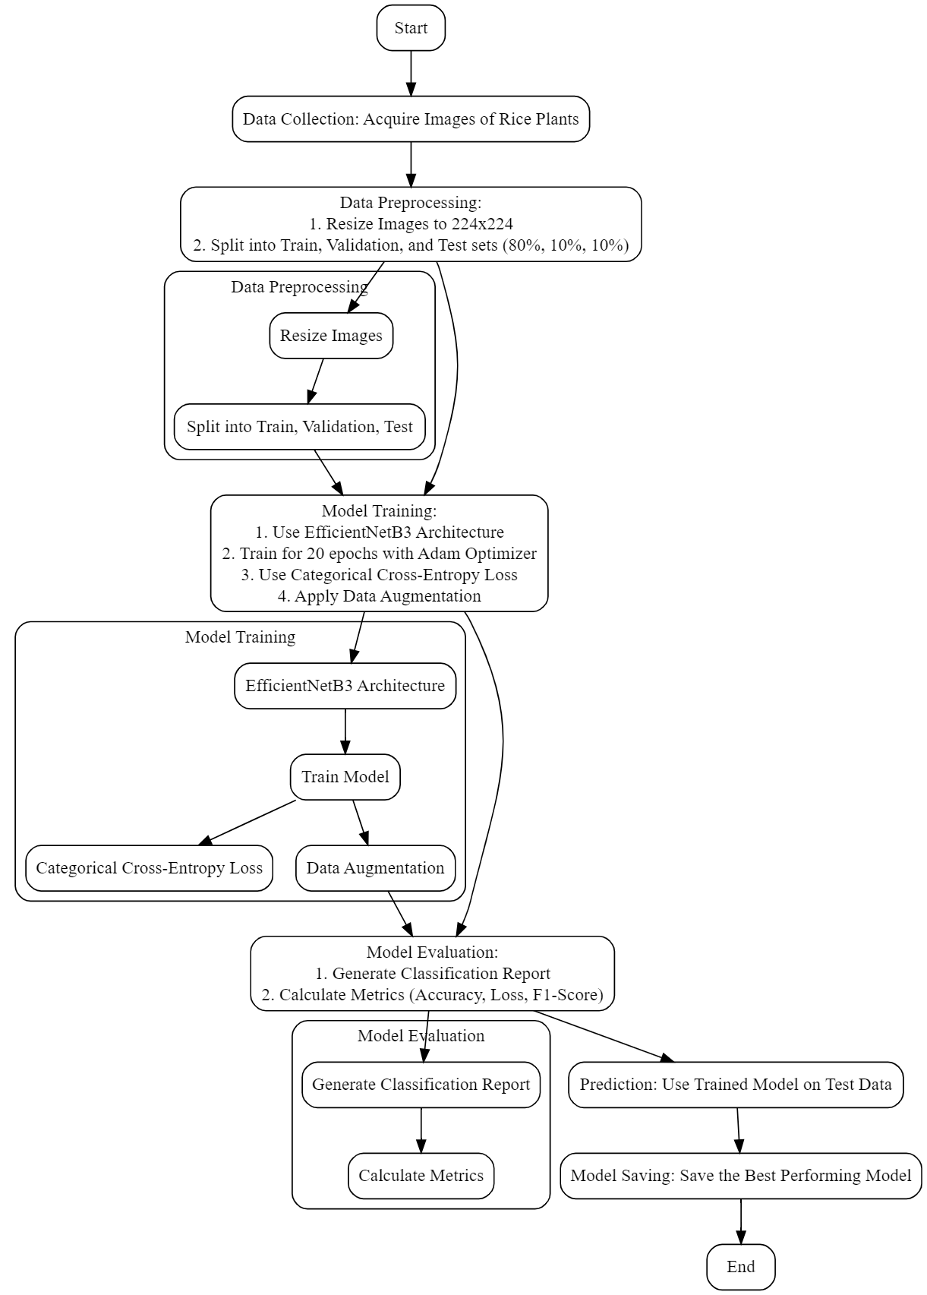

Sample Data:
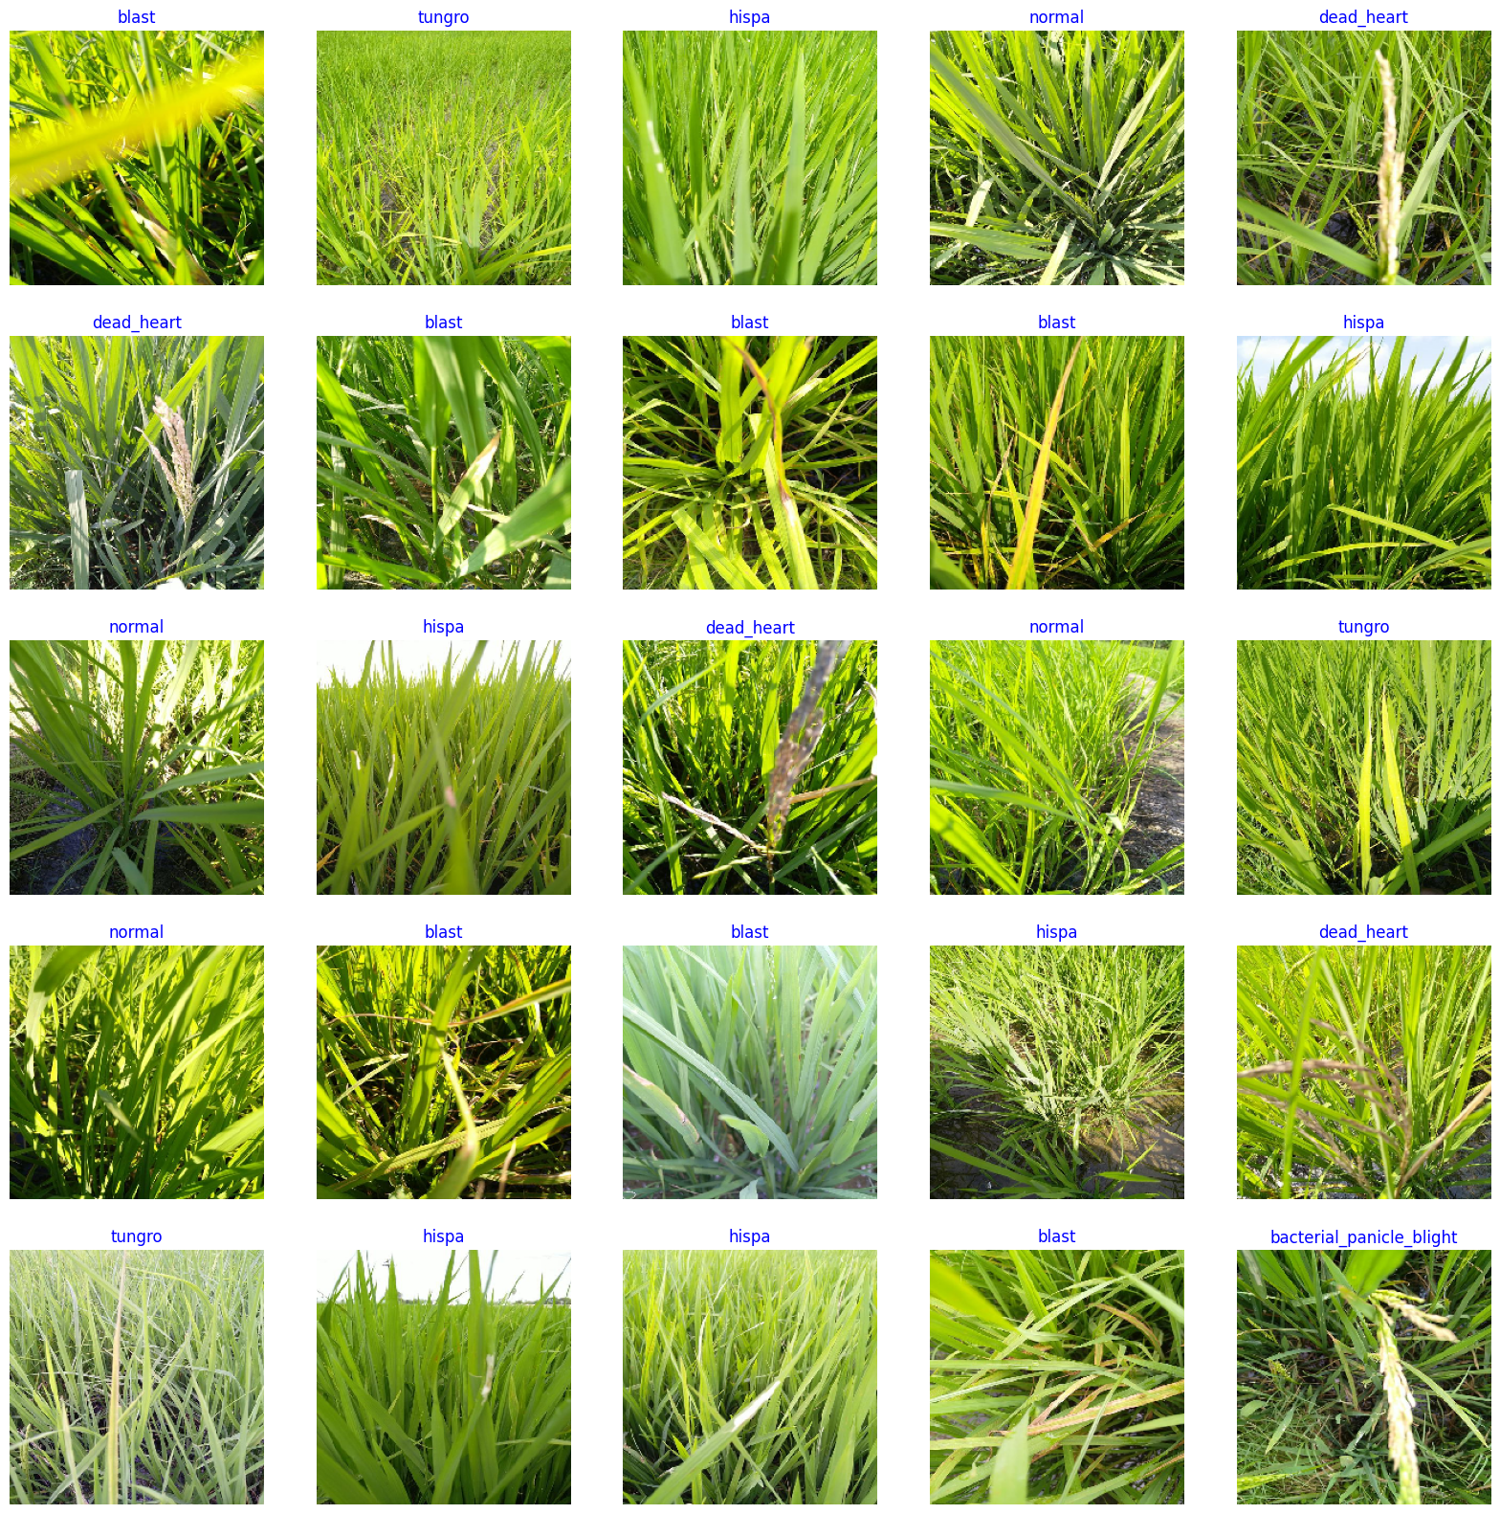
This detailed methodology provides a clear and concise account of the steps taken in developing and evaluating the CNN model. The careful data preparation, training strategy, and evaluation techniques ensure a robust and reliable model for image classification tasks.

